* Screenshot of Model Plot

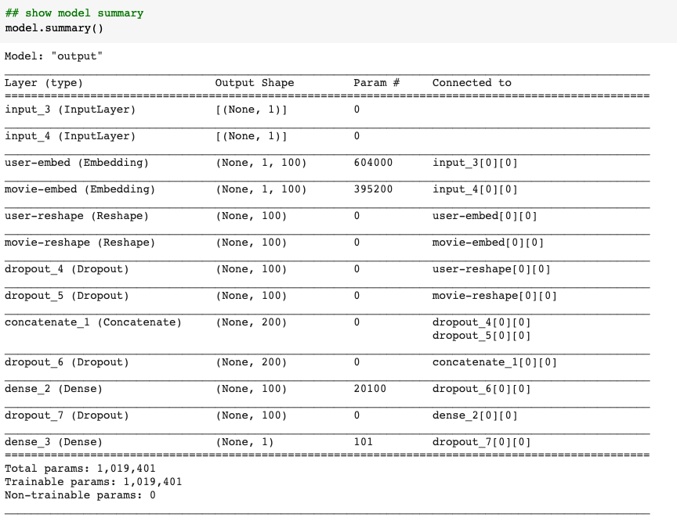

* Screenshot of Test RMSE:

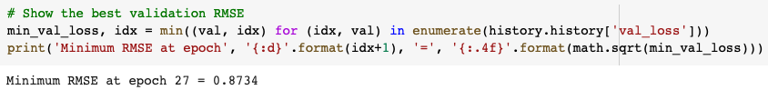

* Screenshot of Model Train and Val Plt plot:

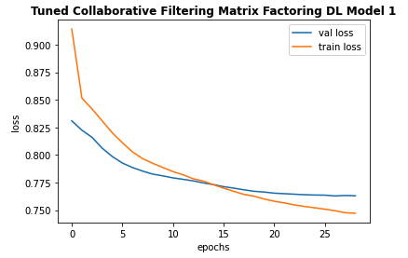

* Tensorboard:
  + Link to Tensorboard: https://tensorboard.dev/experiment/AfVfNNvORAqw3E1to3oeNg/#scalars
  + Screenshot of Tensorboard

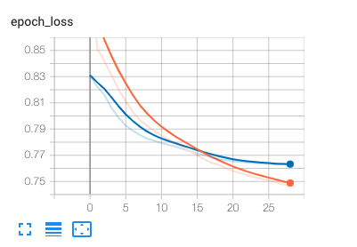

* Ratings Predictions and Movies Recommendation Using Trained Baseline Model
  + Movie Ratings Prediction of User with ID = 2000

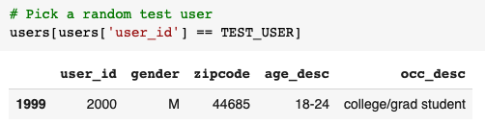

* + Recommended Movies for User with ID = 2000 based on Predicted Ratings

